

APPLICATION DEVELOPMENT
THEORY II
ADT362S
Assignment 2

Group Members
Sinethemba Poni 213276968
Stefano Ngantweni 216283132
Mthuthuzeli Magidigidi

2.1 Requirement Engineering Specification
Functional requirements
We are required to create a system that meets the following requirements:
- The system should allow a customer to place an order
- The system must redirect the customer’s order to the kitchen staff
- Once the order is placed the kitchen staff must confirm that the order has been received and is being prepared, by clicking on their tablet.
- When the kitchen staff/chef is done preparing the order the chef must notify the system that the order is complete and prepared so that a waiter can pick up an order and deliver it to the customer
- There should be three buttons at the table that will be used to determine the status of the table which will be linked to the system
- Once the customer is finished enjoying his/her meal, the customer will use the table tablet to indicate he/she is done with the meal.
- Then the waiter will be notified that the customer is finished so that the waiter can send the bill and the customer may proceed to pay for the meal.
- Once the customer leaves the waiter will use the table tablet to update the state of the table to dirty.
- Once the system updates a table as dirty a notification must be sent to the bus boy to clean the table.
- When the bus boy completes the cleaning of the table the table status will be updated to Available
- The system should keep record of all orders of the specific day, to help the manager to record the day’s business.
- The system must save and organize all the restaurant’s information on the restaurant’s Database automatically

- Stakeholders
- Customers.
- Busboys.
- Waiter.
- Manager.
- Chef.
Feasibility Study
- The system should allow a customer to place an order
- Economic feasibility – Achievable at no cost.
- Operational feasibility – Straight forward and easy to use.
Elderly people with no knowledge of Technology might struggle to use the system. Therefore, a person who can assist those who are struggling to utilize the system might be needed.
- Technical feasibility – Similar technology already exist, so it is a practical proposition.

- The system must redirect the customer’s order to the kitchen staff.
- Economic feasibility – Cost effective.
Cost of guideline for customers on how to use the system.
- Operational feasibility – Provides customers and managers with timely, pertinent, accurate and useful formatted information.
No training needed, can be utilized by intuition.
End users and management will easily adapt to change.
- Technical feasibility – Currently don’t possess necessary technology.
- Once the order is placed the kitchen staff must confirm that the order has been received and is being prepared, by clicking on their tablet.
- Economic feasibility – Cost of hardware and development software (Software and the Tablet).
Possible with the given recourse constraints.
- Operational feasibility – Will provide adequate throughput and response time.
Will provide efficient and reliable services.
- Technical feasibility – Feasible within the limits of the current technology.
It is an achievable proposition.
A tablet will be needed.

- When the kitchen staff/chef is done preparing the order the chef must notify the system that the order is complete and prepared so that a waiter can pick up an order and deliver it to the customer
- Economic feasibility – Hardware costs.
Cost effective – Benefits overweighs the costs.
- Operational feasibility – Will provide cost-effective information to the business.
Will provide fast realizable service.
- Technical feasibility – Similar technology exists already, implantation shouldn’t be a problem.

- There should be three buttons at the table that will be used to determine the status of the table which will be linked to the system.
- Economic feasibility – Hardware costs.
- Operational feasibility – Similar technology exists, therefore, the proposed solution is achievable.
We possess the necessary expertise to achieve this goal.
Customers may resist or not use the new system.
- Technical feasibility – It is a practical solution.

- Once the customer is finished enjoying his/her meal, the customer will use the table tablet to indicate he/she is done with the meal.
- Economic feasibility – Costs for software and hardware.
Benefits overweighs costs.
- Operational feasibility – User friendly, can be used based on intuition - No training needed.
End-user may resist and or not use the system.
- Technical feasibility – Feasible within the limits of current technology.

- Then the waiter will be notified that the customer is finished so that the waiter can send the bill and the customer may proceed to pay for the meal.
- Economic feasibility – Hardware costs.
Benefits overweigh costs.
- Operational feasibility –
Technical feasibility – End-user may resist and or not use the system.

- Once the customer leaves the waiter will use the table tablet to update the state of the table to dirty.
- Economic feasibility – Hardware costs.
Benefits overweighs costs.
- Operational feasibility – Provides fast and reliable services.
Easy to utilize the system – no training needed.
- Technical feasibility – Provide cost-effective information services to the business.
Achievable solution.
s
- Once the system updates a table as dirty a notification must be sent to the bus boy to clean the table.
- Economic feasibility – Hardware costs.
Cost-effective.
- Operational feasibility – Effective and reliable.
- Technical feasibility – Provide cost-effective information services to the business.

- When the bus boy completes the cleaning of the table the table status will be updated to Available
- Economic feasibility – Hardware costs.
- Operational feasibility – Easy to use, no thorough training required.
- Technical feasibility – It is a practical proposition.

- The system should keep record of all orders of the specific day, to help the manager to record the day’s business.
- Economic feasibility – Achievable at no cost.
- Operational feasibility – Will provide managers with timely, relevant, accurate and useful formatted information.
- Technical feasibility – It is practical preposition.
We possess the technical expertise and the necessary technology to develop this kind of system.

- The system must save and organize all the restaurant’s information on the restaurant’s Database automatically
- Economic feasibility – Cost of hardware.
Cost effective.
- Operational feasibility – Will provide end users and staff with timely, pertinent, accurate and useful formatted information.
Training to Mangers and Staff on how to use database.
More reliable and efficient.
- Technical feasibility – Similar technology already exist, therefore, it is a practical solution.

2.2 Roadmap with release plan
Backlogs
- Write up user stories to find out what the users would want the system to do
- Draw up use case diagrams to map out all the activities the system is required to do.
- Write up descriptive use cases to describe what the system should do for each of the users
- Design the database using ERDs
- Draw Class diagrams
- Start developing a prototype system
- Test the prototype
- Review the code
Vision
The end goal of this project is to create an integrated system for a restaurant that will allow the restaurant to move on from the old school pen and paper system.

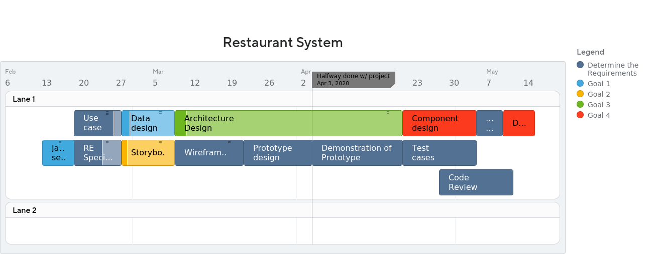
Roadmap

2.3 The software development approach that is not suitable for our project is the waterfall model because the waterfall approach is inflexible. This means that it does not accommodate change after the process is underway. A phase needs to be complete before moving on to the next phase. This model is only appropriate when the requirements are well understood. Changes during the design process also need to be minimal. Since our project requirements are not well defined and our project is going to require constant change, hence we have therefore concluded that the waterfall approach is not suitable for our project.
2.4 Use Case Diagram